**20CSE03 – Building Enterprise Applications**

**Continuous Assessment Test – I**

**Answer Key**

**Part A (10 * 2 = 20 marks)**

1. **Challenges faced by enterprise applications (any 4)**

1. Business Process Automation
2. Data Harmonization
3. Application Integration
4. Application Security
5. Internationalization
6. Transaction Management
7. Rich User Experience
8. Quality of Service (QoS)
9. Technology Selection
10. Governance and team productivity

2.

| **Waterfall model** | **Iterative model** |
| --- | --- |
| This model starts with full requirements | This model starts with partial requirements |
| Does not allow much revision | Easily adaptable for ever changing needs of the projects |
| It can be applied for small projects | It can be applied for large projects |
| Time for production is more | Time for production is less |
| Does not integrate risk management | It handles risk |

3. **Stages in life cycle of enterprise application**

1. Inception

2. Architecting and Design

3. Construction

4. Test

4. **Different types of Business models**

1. AS-IS model

2. TO-BE model

5. **Actors and use cases of Hospital Management System**

**Actors:** Patients, Doctors, Nurses, Receptionist

**Use cases:** Registration, Patients record, Availability of doctors, Prescription etc

6. **Include relationship among the use cases(any one example can be explained)**

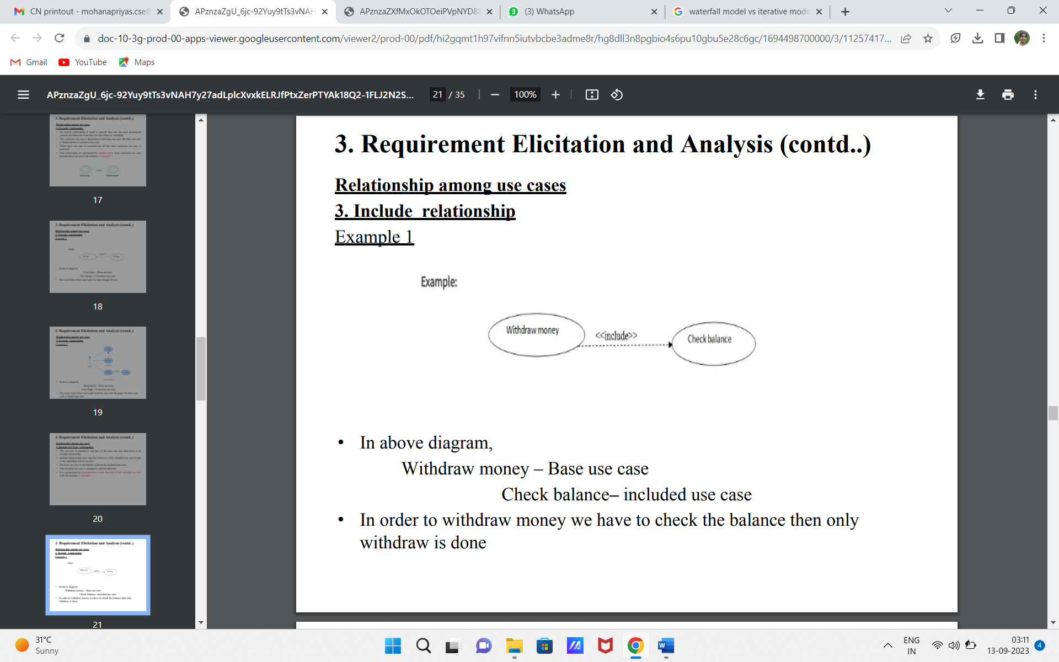

7. **View and Viewpoints**

View: View is how the enterprise application looks like from a selected viewpoint

Viewpoint: Viewpoints is the stakeholders view of the enterprise application

8. **Four Domains of Enterprise Applications**

* + 1. Business architecture
    2. Data architecture
    3. Applications architecture
    4. Technology architecture

9. **Types of classes identified from documented use cases**

1. Entity class
2. Boundary class
3. Data Store class
4. **Association relationship among customer and LoanProduct class**

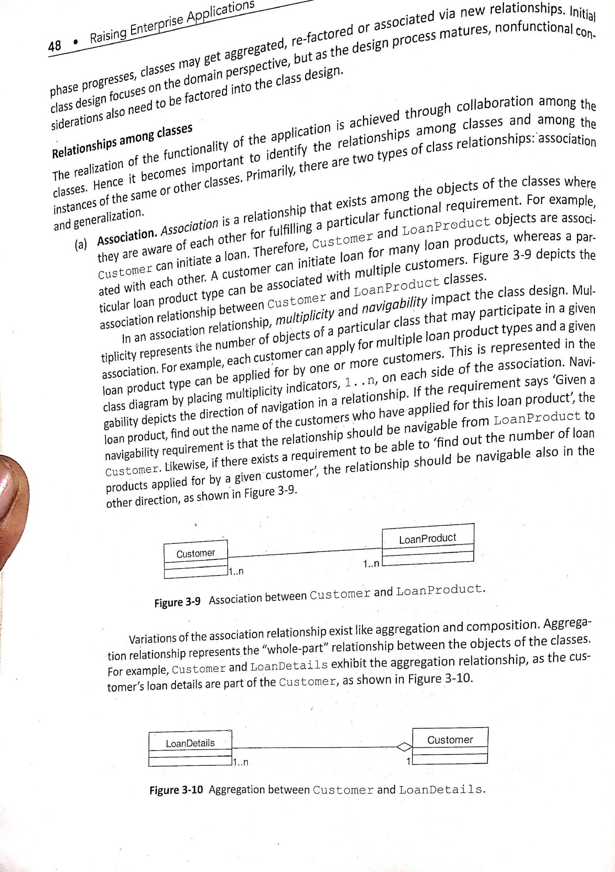

**PART B (3*10 =30 marks)**

1. i) **Skills necessary for Enterprise Applications (any 6 points with each 6 marks)**
2. **Knowledge of organizational dynamics**: understand the organizational business and business needs of end users
3. **Domain knowledge**: understanding of domain
4. **Business analysis skills**: includes domain knowledge, technical knowledge, use of business analysis related tools
5. **Program management skills**: includes planning, estimation, budgeting, talent management, communication needed for managing program
6. **Architecting and Designing skills**: includes the knowledge of architecture views and view points, architectural patterns, design patterns, design paradigms like object orientation, aspect orientation and service orientation, usage of design tools, architectural and design best practices, technical frameworks, knowledge of modeling languages like Unified Modeling Language, etc.
7. **Programming skills**: includes knowledge of a programming language ,knowledge of the underlying platform, knowledge of an Integrated Development Environment (IDE) tool, programming best practices, code review skills, knowledge of unit testing tools, configuration management and build tools, static code analysis tools and dynamic code analysis tools etc
8. **Testing skills**: includes skills for performing integration testing, performance testing, load testing, stress testing, application security testing, interface testing and user acceptance testing.
9. **Knowledge of tools**
10. ii) **Measuring the success of Enterprise Applications (any 4 points with 4 marks each)**
11. **Effectiveness of the solution** - measured by acceptance of application by end users
12. **Quality of Enterprise Application** - measured by performance, scalability, defect free code etc
13. **Time to Production** - Total time taken from first stage to last stage of the application development - It should be less
14. **Cost Effectiveness** - it determines Expenditure vs benefits of the enterprise application - it is determined by Return on Investment(RoI)
15. **Budget and schedule adherence** - application should be within budget and developed within time - should not overruns budget and exceeding timeliness
16. **Productivity** - depends on development team - Reuse, use of best practices, frameworks and tools, automation for better productivity
17. **AS-IS model**  (5 marks)

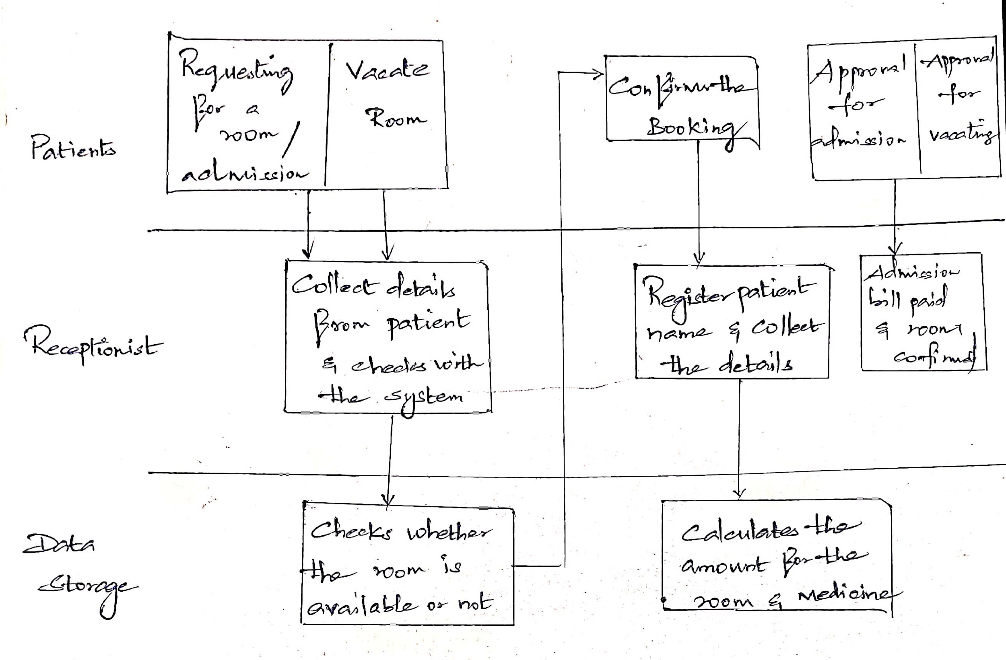

**TO-BE model** (5 marks)

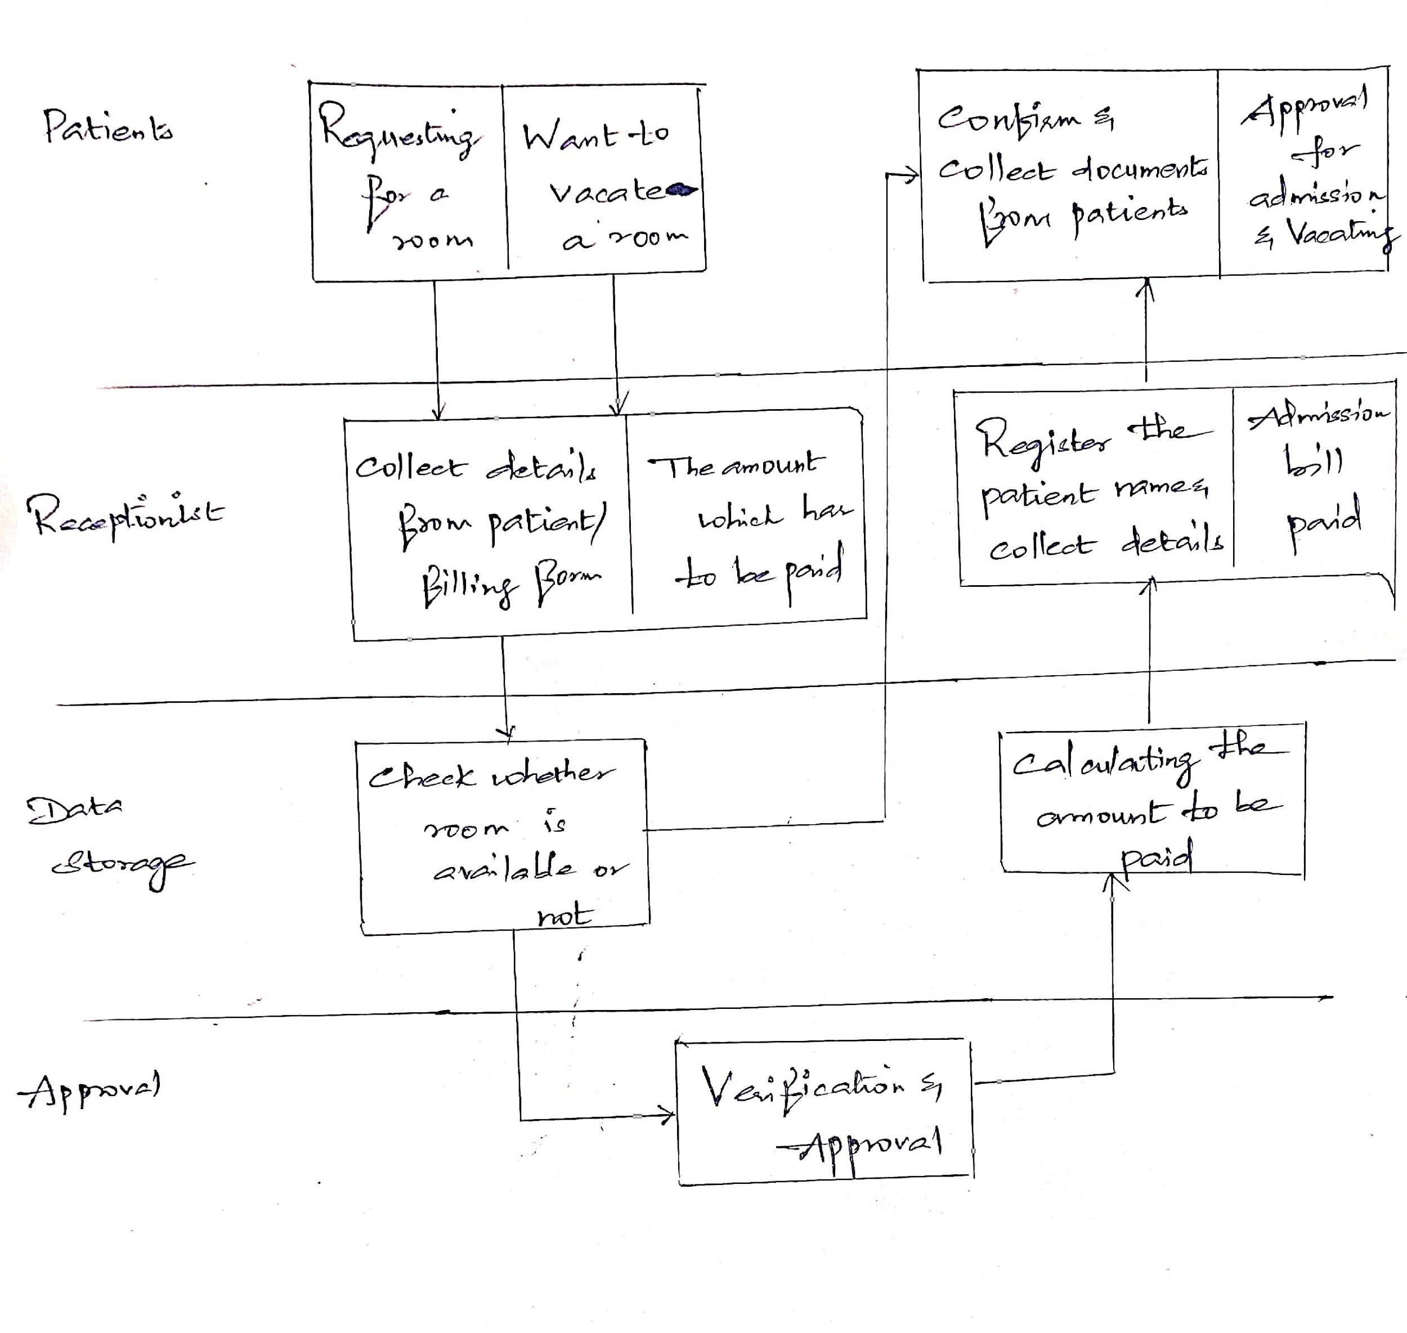

13.**Use case diagram for the given scenario**

Actors : 3 marks

Use cases: 7 marks

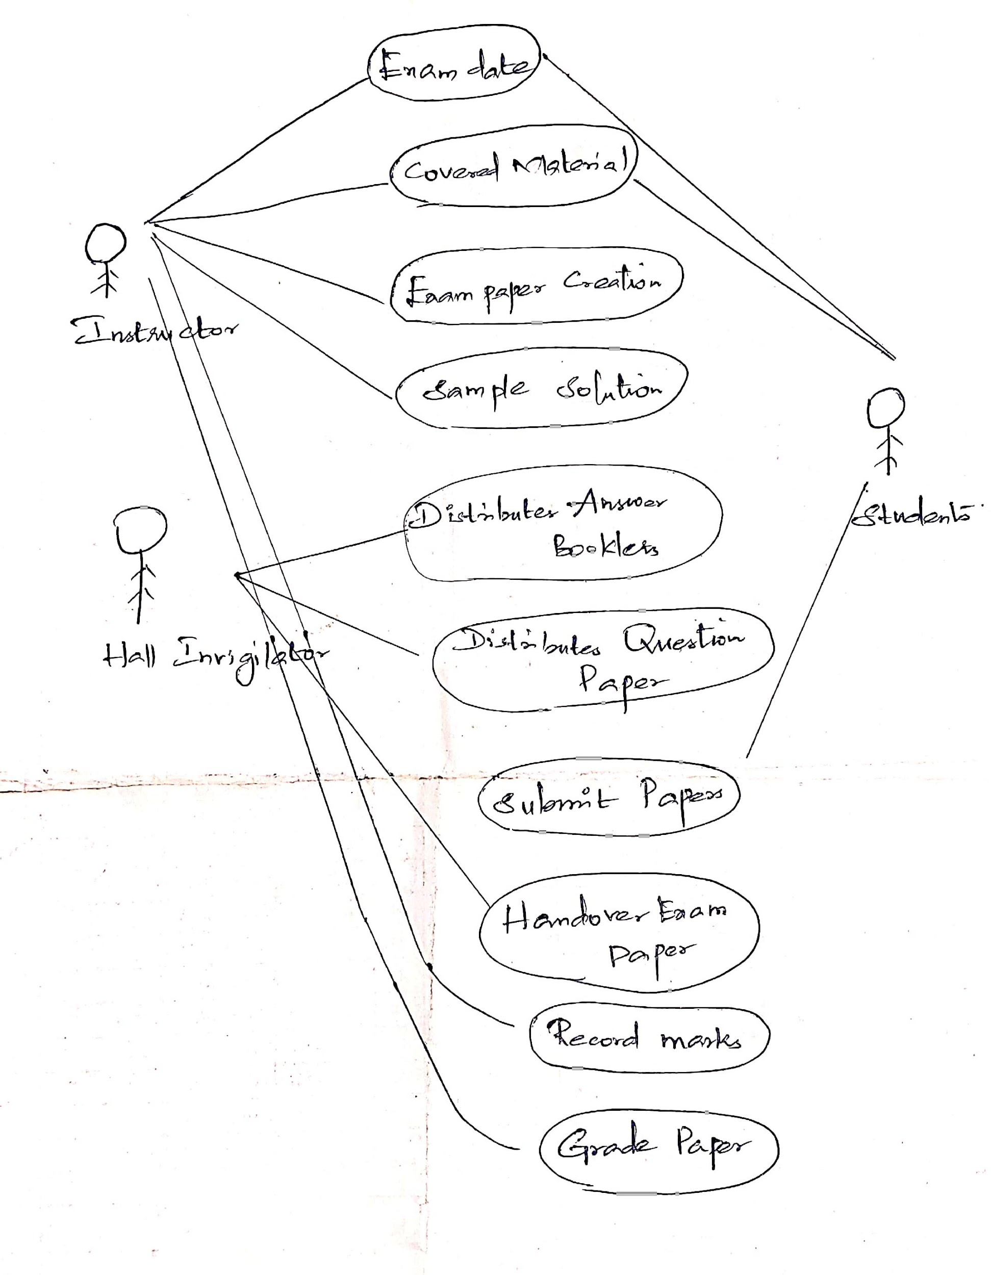

14. **Different Layers of Logical Architecture**

**Logical Architecture (1 mark)**

* Elements of business architecture define the functionality of a given enterprise application.
* This functionality can be mapped to a set of logical building blocks which implement the enterprise application.
* These logical building blocks together define the logical architecture of an enterprise application.
* The logical architecture serves as the blueprint to the architects to arrive at an optimal enterprise application solution.
* Logical architecture is the bridge between requirements captured and implementation

**Diagram (5 marks)**

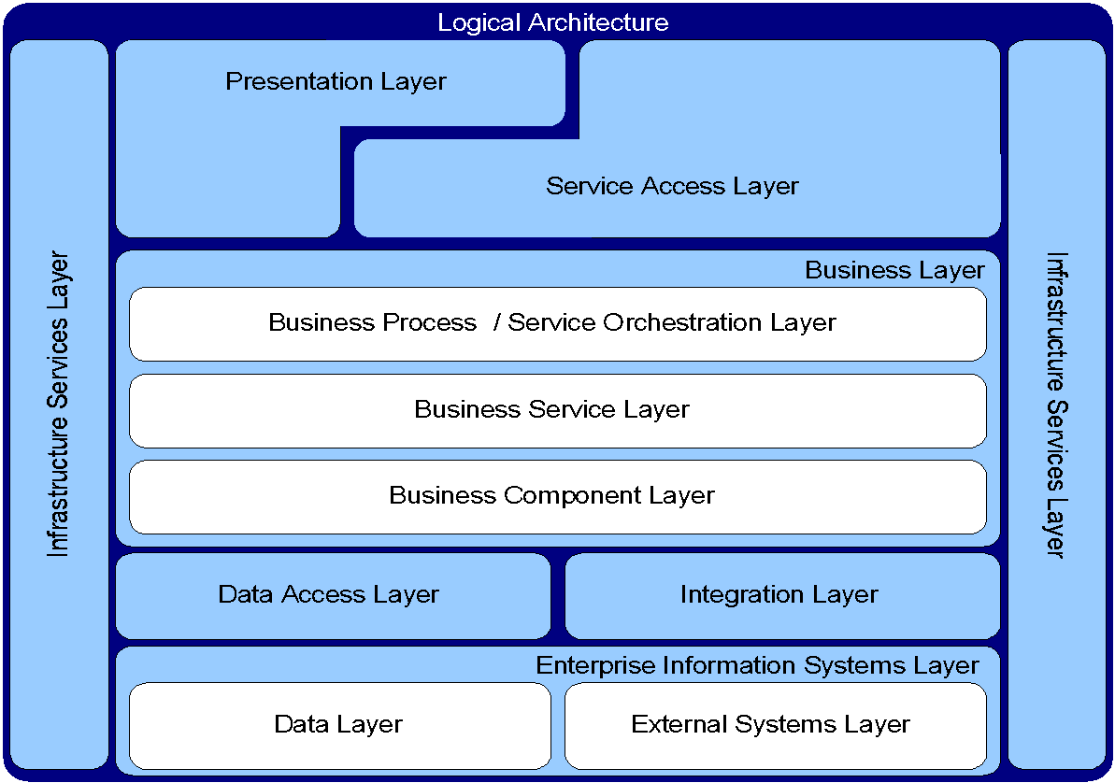

**(Explanation of layers 4 marks)**